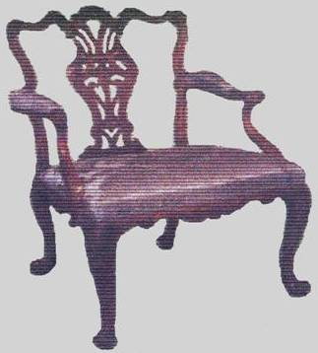
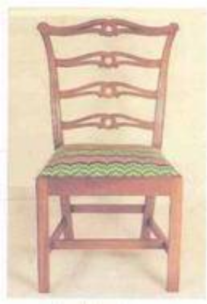
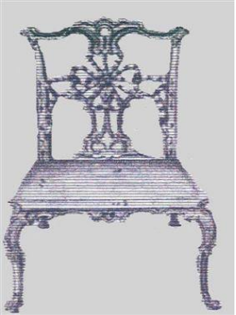

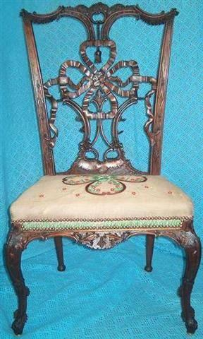
From Left to Right:
1, The Ribbon-back Chair by Joseph Hemingway, 2007.
2, The Design, for the Ribban-Back Chair, by: Thomas Chippendale, 1754.
3, The Ribbon-back Chair: by Thomas Afflieck, America, 1760 (C.)
4, A Spat Backed chair, sold in the, UK 2003? : Taylor & Hobson Ltd, Norman Holroyd, 1950.

The Impossible Dream 2.
Dr Joseph Hemingway: Master Carver, Furniture Maker.
A Lifelong Admirer of Thomas Chippendale.

Thomas Chippendale Furniture Ltd: Reports

“At the age of four some children still can’t tell the potty from the toilet, but Joseph Hemingway, already knew what he wanted to be. His mother noticed his keen interest at that early age, and introduced him to The Gentleman and Cabinetmakers Director 1762. This book has become the most important book in Joseph’s life.”

On leaving school, ‘Joseph’ gained a cabinet making apprenticeship with ‘Taylor & Hobson Ltd’ ‘Mechanics in Wood’, Huddersfield, West Yorkshire, England. At this cabinetry firm, ‘Joseph’ met: ‘Norman Holroyd’, who became his Caving Mentor. ‘Norman’ was extremely knowledgeable in ‘Rococo Theory & Design’ and working with him at ‘Taylor & Hobson’s’, Say’s Joseph: The days were never long enough. Joseph recalls fondly one of Norman's lessons: “The History of ‘Taylor & Hobson Ltd’ Starting back in 1851, two very old firms ‘Albert Taylor & Son’s Ltd’. (1840) and ‘F B Hobson & Son’s Ltd’ (1851) came together in ‘1899’ to create ‘Taylor & Hobson Ltd’. This combination made one very large successful business! There had expanded into: 10 adjoining shops premises and all in one tight block, 5 on New Street and 5 on Cloth Hall Street, in Huddersfield’s City Centre.”

Upon reading in the local Huddersfield newspaper, ‘The Examiner’, that the history of ‘Taylor & Hobson’ went back further, Joseph has explored this history further and is displaying his findings: In 1754 ‘Thomas Chippendale & Co’ took on their very first apprentice, ‘Nathaniel Hobson’ at his workspace at St Matins Lane. London. Did Nathaniel Hobson realise that Matthias Darly was to leave in a hurry later that year, after a most frantic row with Thomas Chippendale? The argument was said to be concerning a 4 Poster Bed Design. Published in the 1754 Director: Note: a‘Doom’ instead of: ‘a Domed Bed’. Then in 1755, a fire, mysterious, destroyed Thomas Chippendale & Co, the new workshop one Windy Saturday evening. ‘Chippendale & Co ‘managed to overcome their damage helped, by ‘Thomas’s’ cousin, ‘William Chippendale’ Who was the ‘Master Builder’, from Fernley, near Otley. ‘Chippendale & Co’ was wise to have taken out insurance with The Sun Insurance Company, only 2, months before there fire, and were paid the sum of £847, 12,6d in compensation? This makes one wonder: Did: ‘Chippendale smell a Rat’ another question: Why did ‘Thomas Afflieck’ leave England in such a hurry, bound for New England in 1756?”

Joseph’s interest in the history of ‘Thomas Chippendale’ and his dedication to creating the furniture designs in the director has resulted in ‘The Ribbon-back Chair’ coming to fruition. Although the value of Joseph’s ‘Impossible chairs’ has been much debated, ‘The Philadelphia Museum Art’ valued one chair at £3M,in 2003.His Finest Critic, ‘Paul Ferguson’, Past President of: The UK’s; ‘ Master Carver Association’. Who was instimental in Selling? As a ‘True’ Chippendale ‘Ribbon-back Chair’15/10/2003 for: £386,400. To a: ‘Wealthy American’ Collector:, this was Josephs Cue, to started exploring the ‘Book’ Norman’s Pet Name. It soon became clear that a missing link had to be fund, not shown in the ‘Director’. Jo discovered this by 2005. When he discovered the Italian Architect, ‘Giovanni Battista Piranesi’. The amazing ‘Roman’, who had aspirations to rebuild fallen Rome. ‘Mathias Darly’ studied in Rome, studying Piranesi ‘Designs’ before meeting ‘Thomas Chippendale’ in 1748 in London.”

The additional information found by Joseph’s research as influenced the chair you see today. And add to the inspiration of Chippendale’s original designs of this chair. Joseph has at this time, appointed a dedicated timber firm to supply him with the Wide Mahogany for the Ribbon-back. Also a friendly local Blacksmith has forged the extra long cranked chisels which were designed especially by Joseph to carve this intricate masterpiece in wood. The specialist tools are vital to carve the delicate detail, but more importantly the skill, knowledge and precision of Joseph’s hands needs remembering. The rich dark finish of the winding wood seems like an Impossibility, but Joseph has proved that a medium so strong and firm can be made to almost dance like a flowing vine, Sprouting into a lively Ribban.
New Book 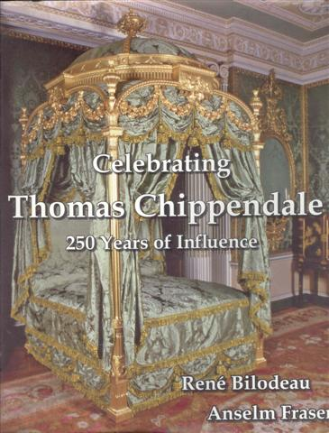
Rene Bordeaux
ISBN: 0-9762`124-0-4
learningmill@bellsoulth.net

On sale from: René Bordeau ISBN.0-9762124-0-4

Joseph Hemingway is featured in Dr Renés Bordeaux’s book (right) and more information about Joseph Hemingway’s Ribbon-back Chair and other pieces of work can be found at: http://www.thomaschippendalefurniture.com
Contact: josephhemingway@btconnect.com

