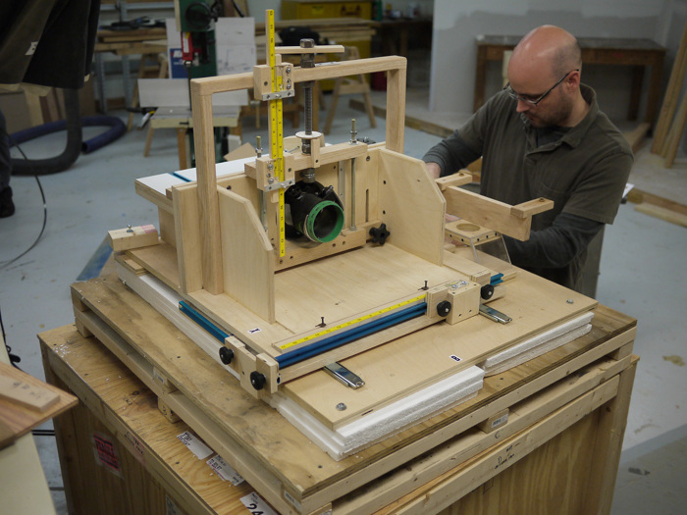

www.finewoodworking.com

Homemade Horizontal Router Table
By Matthew Kenney May 18, 2010

Big tool, big crate. Here I am unpacking the horizontal router table. And, yes, it is sitting on the crate it was shipped in.

We get some unique mail here at Fine Woodworking, like carvings, miniatures, wood samples, and I once even got a block plane. But the most interesting thing I’ve gotten in the mail has to be the horizontal router table sent to me by a reader from South Carolina. He sent it to us so that we could test it out and consider it for the magazine. We’ve run articles on horizontal router tables in the past, but this one is a bit different. Typically, the table is made to slide on two axes and the router is stationary. The maker of this table switched that up. The router moves in three axes and the table (and workpiece) is stationary. To get a sense of how the table works check out this quick (and rough) video of me using it back in the shop.

Wanna Build It?
If you’re interested in building a rig like this, be sure to check back in the coming weeks for a link to the plans. We hear the inventor of this table will be putting his design onto paper!
More Details
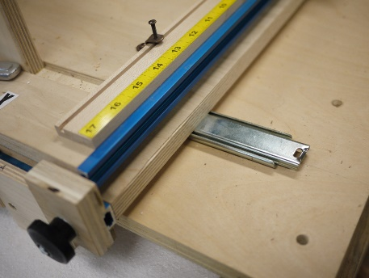 Router Glides on Slides
One pair of slides lets the router move toward and away from the workpiece. Another lets it roll along the workpiece.

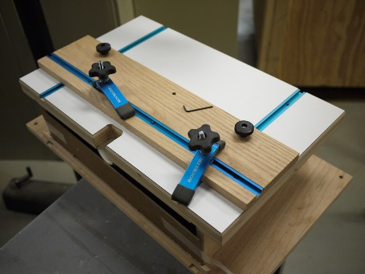 A Stationary Table
A fence and hold downs lock parts in place for routing along the grain. A second fence enables end grain routing.

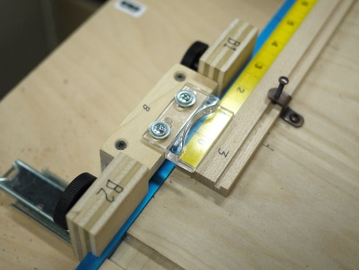 Precise Control
There is a rule and cursor so that you can control the exact length of a mortise and get repeatable results.

