http://woodtools.nov.ru/subjects/router_table/router_table1.htm
Pat Warner’s Micro Adjustable Router Table Fence
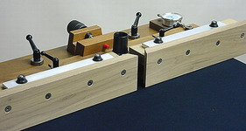

This 2-stage (micro and macro-adjust) fence is a precision tool designed for joinery and other close cuttings.  The fence halves slide left and right, closing at 1" with a maximum opening of 3". When fully opened the fence measures ~30" x 3-1/2" high. In my view, routers should not see cutters greater than 2-1/2" in diameter, that is about the maximum this fence will accommodate.  The outfeed fence can be adjusted positively to ~.045" for full thickness cuts (jointing e.g.) and negatively to ~ .010" when it is not needed (stopped mortices, e.g.).  The walnut faces of the T-section fence assemblies are sanded and scraped to a flatness of .0015" and left unfinished for future trueing due to wear and warp. They are squared and calibrated (shimmed if necessary) to less than 0.5 degrees to my standard table before shipment.  The fence is a 5 layered laminate when clamped to your tabletop; a very rigid assembly and quite resistant to deflection and cup. It is lever-clamped to a pair of tee nuts under the table top for quick and rough positioning, (2"). The micro-adjustable sub-assembly also has a generous 2" of travel, 1" of which is monitored with a dial indicator; the full travel is measured with a 3" precision Starrett rule. The indicator can be used to measure the waste/cut on the actual workpiece but not throughout its full travel.  Parallelism and fence displacement adjustments are facilitated with a .015" x 12" feeler gage (supplied) and a ground straight edge (not supplied). The micro-adjustment is actuated with a 5/16-18 leadscrew and knob. The fence should be locked at its end point (anywhere in its travel) for minimum deflection. Deflection of the entire fence, when subjected to a 25 pound force at the end of either face, with all levers locked is ~.001 to.003".  The fence is supplied with a tapered B&D vacuum funnel for a 1-1/4" to 1-1/2" I.D. vacuum hose. Collection is good, depending on the cutter, its location within the fence and vacuum quality. The fence is shipped complete with all hardware, calibrated and assembled. A 5/16" transfer punch is provided to facilitate the location of the receiver tee-nuts for the table lock-levers.  This fence is not an accident; a lot of R&D and 2 years of field testing have proven the design is correct for its intention. It can be indexed, calibrated to the work, zeroed, and positioned in seconds. This is a serious tool and timesaver for the serious woodworker. Precision joinery and close tolerance experimental cuttings are its forte: ordinary work will be more than expeditious.  Price: 425$ + 40$ for boxing (double), insurance, tax and freight, (UPS Ground). Price includes an hour of free instruction if the user can travel to Escondido, California.  Fence plans are available in FineWoodworking issue no. 144, see the Taunton.com site for copies. Don't expect to breeze through the instruction plan. Nonetheless there is enough information for the more experienced to build the thing without much ado. It could be a fun challenge for anybody.  While it is a true, a good router table fence is key to the accuracy and expedition of table routing, a simple straight stick may suffice for a substantial amount of ordinary work. One example is the simple pivot fence in my second CD. That fence uses 50 cents worth of MDF, a 20 cent bolt, an hour of your time, and with a PC dust collector (39700) you won't have any chip messes. | 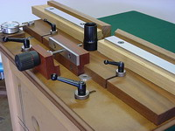
 | Rough and fine adjustments (east/west) are made quickly with a set of levers and lead screw. At a given setting there is 2" of quick travel and 2" of micro-adjust. The fine-adjust section travels in a straight line on a set of 1/4" x 1" aluminum bars. The cutter opening ranges from 1" to 3".
 | 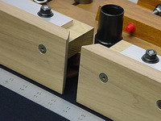
 | The fence closes down to 1" and opens to 3"
 | 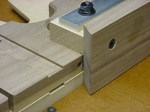
 | 5 Layers of fence (including your tabletop) render this assembly very resistant to deflection. Each layer is bolted to the next. The fence faces are flattened to .0015", tongue and grooved to a stiffener and bolted in 4 places to resist any force you apply to it. The stiffener is flattened with a bar of 3/8" thick x 1-1/4" aluminum.

